Other Books-in-Print
by McFarland & Company, Inc.
(Order Online: http://www.mcfarlandpub.com/)
(Order Toll Free Number: 1-800-253-2187)

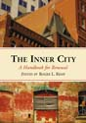 | The Inner City: A Handbook for Renewal (2001, 2007)  Covers the evolving national best practices of local governments in the use  of municipal economic development tools to stimulate inner-city renewal.  Roger L. Kemp, Editor
Homeland Security Handbook for Citizens and Public Officials (2006)
Covers the evolving national best practices of local governments in the new
and expanding field of homeland security.
Roger L. Kemp, Editor
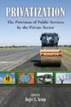 | Privatization: The Provision of Public Services by the Private Sector (1991, 2007)  Covers the evolving national best practices of cities in the evolving field of using  privatization practices to provide public services by the private sector.  Roger L. Kemp, Editor
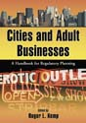 | Cities and Adult Businesses: A Handbook for Regulatory Planning (2010)  Covers the evolving national best practices of cities in the use of municipal policies  and regulations to manage the locations and operations of adult businesses.  Roger L. Kemp, Editor
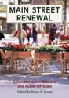 | Main Street Renewal: A Handbook for Citizens and Public Officials (2000, 2006)  Covers the evolving national best practices of cities in the field of utilizing  economic development tools to stimulate main street and inner-city renewal.  Roger L. Kemp, Editor
Cities and Sports Stadiums: A Planning Handbook (2009)
Covers the evolving national best practices used by cities in the field of utilizing
municipal stadiums and arenas as vehicles to stimulate inner-city renewal.
Roger L. Kemp, Editor
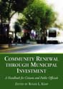 | Community Renewal through Municipal Investment: A Handbook for Citizens & Public Officials  (2003, 2007)  Covers the national best practices used by cities in the evolving field of utilizing  municipal self-investment policies and practices as vehicles for urban renewal.  Roger L. Kemp, Editor
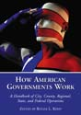 | How American Governments Work: A Handbook of City, County, Regional, State, and  Federal Operations (2002, 2007)  Covers how all levels of government – federal, state, regional, and local -- are  organized and operate in the United States of America.  Roger L. Kemp, Editor
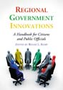 | Regional Government Innovations: A Handbook for Citizens and Public Officials (2003, 2007)  Covers the national best practices in the evolving field of regional governance and  the use of innovative regional government programs and services.  Roger L. Kemp, Editor
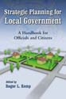 | Strategic Planning for Local Government: A Handbook for Officials and Citizens (1993, 2008)  Covers the national best practices used by cities in the evolving field of municipal  government strategic planning programs and practices.  Roger L. Kemp, Editor
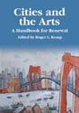 | Cities and the Arts: A Handbook for Renewal (2004)  Covers the national best practices used by cities in the evolving field of utilizing the  arts as an economic development vehicle for both main street and inner-city renewal.  Roger L. Kemp, Editor
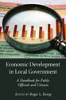 | Economic Development in Local Government: A Handbook for Public Officials and Citizens  (1995, 2007)  Covers the national best practices used by cities in the evolving field of utilizing  innovative municipal economic development programs to create jobs and revenues.  Roger L. Kemp, Editor
Museums, Libraries and Urban Vitality: A Handbook (2008)
Covers the national best practices used by cities in the evolving field of how museums
& libraries are being utilized as tools for economic development and redevelopment.
Roger L. Kemp and Marcia Trotta, Editors
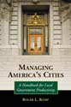 | Managing America’s Cities: A Handbook for Local Government Productivity (1998, 2007)  Covers the national best practices used by cities in the evolving field of local  government productivity on a department-by-department basis.  Roger L. Kemp, Author
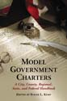 | Model Government Charters: A City, County, Regional, State, and Federal Handbook  (2003, 2007)  Covers the model charters used for the major forms of government at all levels --  national, state, regional, and local -- in the United States of America.  Roger L. Kemp, Editor
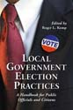 | Local Government Election Practices: A Handbook for Public Officials & Citizens (1999, 2006)  Covers the national best practices used by cities in the evolving field of utilizing  proven and effective local government election management practices.  Roger L. Kemp, Editor
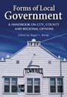 | Forms of Local Government: A Handbook on City, County and Regional Options (1999, 2007)  Covers the most commonly used national models of local government - - city,  county, and regional -- that are used in the United States of America.  Roger L. Kemp, Editor
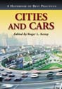 | Cities and Cars: A Handbook of Best Practices (2007)  Covers the national best practices used by cities in the evolving field of how to  improve upon and overcome the negative impacts created by the excessive use of  automobiles.  Roger L. Kemp, Editor
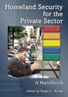 | Homeland Security for the Private Sector: A Handbook (2007)  Covers the evolving national best practices used by the private sector in the new and  evolving field of homeland security.  Roger L. Kemp, Editor
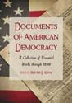 | Documents of American Democracy: A Collection of Essential Works (2010)  Covers the major historical documents leading to the evolution, development, and  refinement of the democratic form of government in the United States of America.  Roger L. Kemp, Editor
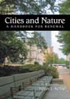 | Cities and Nature: A Handbook for Renewal (2006)  Covers the evolving national best practices used by cities to restore nature to the  main streets and inner-city neighborhoods of communities throughout America.  Roger L. Kemp, Editor
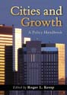 | Cities and Growth: A Policy Handbook (2008)  Covers the evolving national best practices used by cities to initiate positive policies  and programs to manage the future impacts of urban growth and development.  Roger L. Kemp, Editor
Cities and Water: A Handbook for Planning (2009)
Covers the evolving national best practices used by cities to restore their wetlands,
watersheds, shorelines, rivers, and other valuable public water resources.
Roger L. Kemp, Editor

